## NON-SYLLABUS PROJECT REPORT

## ON

**WAR_N_CHASE**

**Bachelor of Technology**



**Poornima University Jaipur**

**Session: 2021-2022**

### Submitted By:

### Parbat Singh (2021PUSCEBADX09772)

**Mansha Sharma(2021PUSCEBADX10296)**

**Submitted To:**

### Department Of 1ST Year, Poornima University

**School Of Engineering And Technology, Poornima University**

**School of Computer Science and Engineering, Poornima University**

**IS-2027-2031, Ramchandrapura, P.O. Vidhani Vatika, Sitapura Extension,**

**Jaipur, Rajasthan (India) 303905**

# CANDIDATE’S DECLARATION

We hereby declare that the work presented in the major project report entitled “**WAR_N_CHASE**” is submitted by **Parbat Singh (2021PUSCEBADX09772) and Mansha Sharma (2021PUSCEBADX10296)** is in the fulfillment of the requirements for the award of the degree of Bachelor of Technology specialization in Artificial Intelligence and Data Science, Poornima University, Jaipur. The work has been found satisfactory, authentic of my own work carried out during my degree, and approved for submission.

The work reported in this has not been submitted by me for the award of any other degree or diploma.

**Date :**

**Parbat Singh**

**Mansha Sharma**

ii

**CERTIFICATE**



This is to certify that the major project report entitled “**WAR_N_CHASE**” is submitted by **Parbat Singh 2021PUSCEBADX09772 and Mansha Sharma 2021PUSCEBADX10296** students of 1st year 1st semester in partial fulfillment of the degree Bachelor of Technology specialization in Artificial Intelligence and Data Science, Poornima University, Jaipur during the academic year 2021-2022. The work has been found satisfactory and is approved for submission.

### Mr. Vishal Harith

### ASSISTANT PROFESSOR

SCHOOL OF COMPUTER SCIENCE AND TECHNOLOGY

### Mr. Pratish Rawat Dr. Ajay Khunteta

HOD DEAN

DEPARTMENT OF 1ST YEAR SCHOOL OF COMPUTER SCIENCE AND ENGINEERING

iii

**ACKNOWLEDGEMENT**

It is our privilege to express our sincerest regards to our project coordinator, **Mr. Parminder Singh,** for his valuable inputs, able guidance, encouragement, whole-hearted cooperation, and constructive criticism throughout the duration of our project. Many thanks to our project guide, **Mr. Vishal Harith**, who has given his full effort in guiding the team for achieving the goal as well as his encouragement to maintain our progress on track.

We would like to express our heartfelt appreciation to all faculty members whose direct or indirect suggestions helped us to develop this project. We pay our respect and love to our parents and all other family members and friends for their love and encouragement throughout our careers.

**Parbat Singh**

**2021PUSCEBADX09772**

**Mansha Sharma**

**2021PUSCEBADX10296**

iv

**ABSTRACT**

For a computer science student, it is very necessary to have a grip over any particular programming language and no doubt over the importance of python programming language in today’s era.

So, this project was chosen by my team in order to increase our programming skills and advance in Object Oriented Programming and game development.

For sure the best way to learn anything is enjoying your work while you do it and what can be better than creating games by your own while learning so many concepts alongside.

This project is basically an arcade shooting game based on pygame library of python programming language in which there is a main character whose aim is to clear a level while killing enemies using guns and grenades.

This game is created already by a programmer and we are creating this game again by following his YouTube videos.

After completion of this project we would have a better understanding of Object Oriented Programming and pygame library and a better understanding of how games actually works.

v

**TABLE OF CONTENT**

* FRONT PAGE i
* CANDIDATE’S DECLARATION ii
* CERTIFICATE iii
* ACKNOWLEDGEMENT iv
* ABSTRACT v
* TABLE OF CONTENTS vi
* Introduction 1
* List of Figures 2
* Working of project 4
* Result analysis 5
* Future Scope 6
* Conclusion 7
* REFRENCES 8

vi

**INTRODUCTION**

Our team have created a project(game) using the python language and with the support of our respected guide Mr Vishal Harith. As human nature seek for fun and entertainment most of the time.

Games fulfill the quota of entertainment in anyone’s life. Not only entertainment games help to develop the strategical mind, reflexes of mind, skills, challenging spirits, imaginations, and also motivate students to take risk, etc. But the progress that game does to our mind is not visible in one or two day, it has to be practiced on a regular or daily basis.

Game Engines can make the process of creating a game much easier and enable developers to reuse lots of functionality. It also takes care of rendering for 2D and 3D Graphics, physics and collision detection, sound, scripting and much more.

Some Game Engines have a very steep learning curve such as CryEngine or Unreal Engine. Yet, other tools are very accessible to beginners and some do not even need you to be able to write code to create your game, e.g Construct 2. The Unity Game Engine ranges somewhere in the middle, while it is beginner friendly, some popular and commercial games have been built using Unity (e.g. Overcooked, Superhot). Game Development is the art of creating games and describes the design, development and release of a game. It may involve concept generation, design, build, test and release. While you create a game, it is important to think about the game mechanics, rewards, player engagement and level design. A game developer could be a programmer, a sound designer, an artist, a designer or many other roles available in the industry. Game Development can be undertaken by a large Game Development Studio or by a single individual. It can be as small or large as you like. As long as it lets the player interact with content and is able to manipulate the game’s elements, you can call it a ‘game’. Games nurture optimism and create positive emotions. Gaming teaches players how to deal with frustration and anxiety. Gaming promotes social skills; more than 70 % of the gamers play, either competitively or co-operatively, with a friend.

**LIST OF FIGURES** 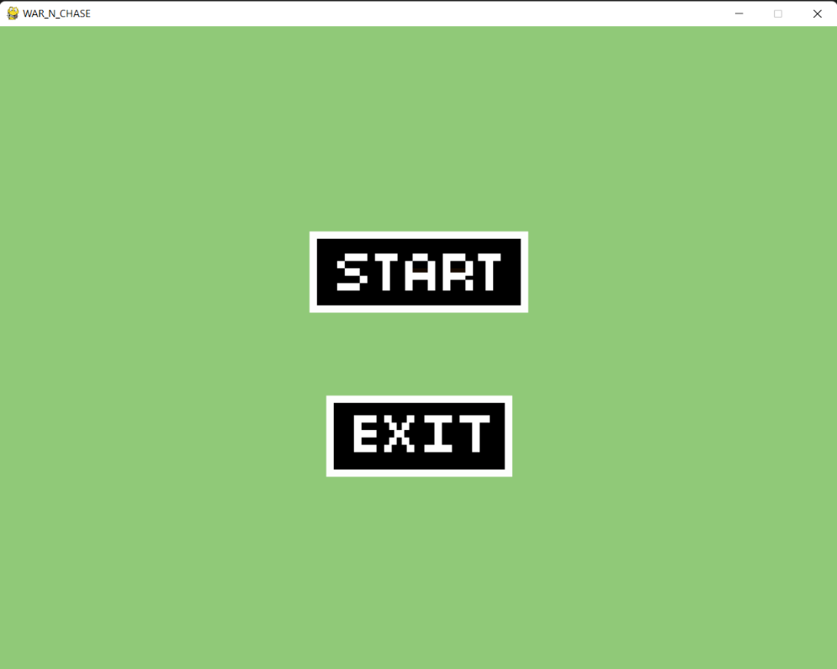

**FIGURE 1**

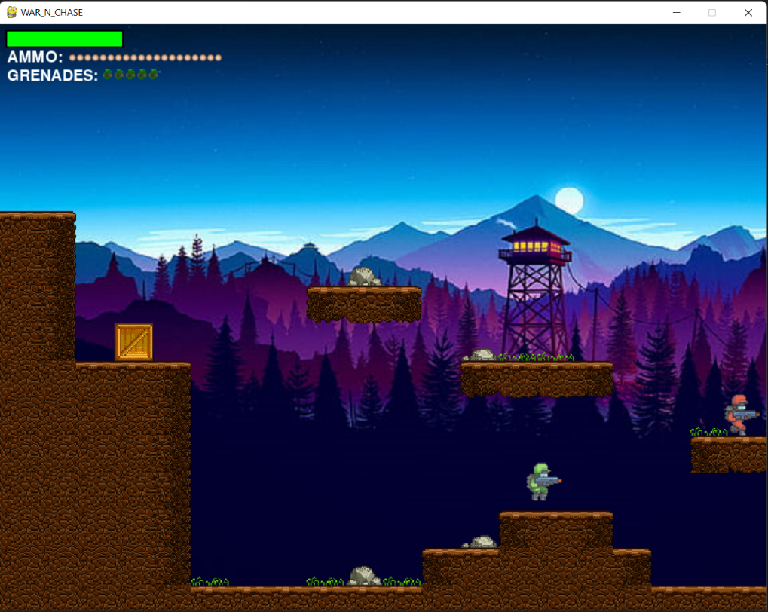

**FIGURE 2**

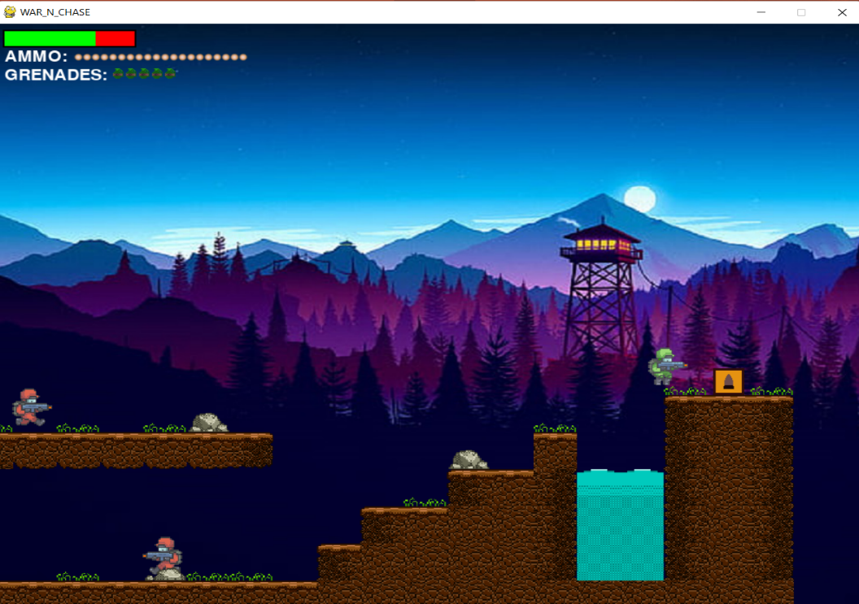

**FIGURE 3**

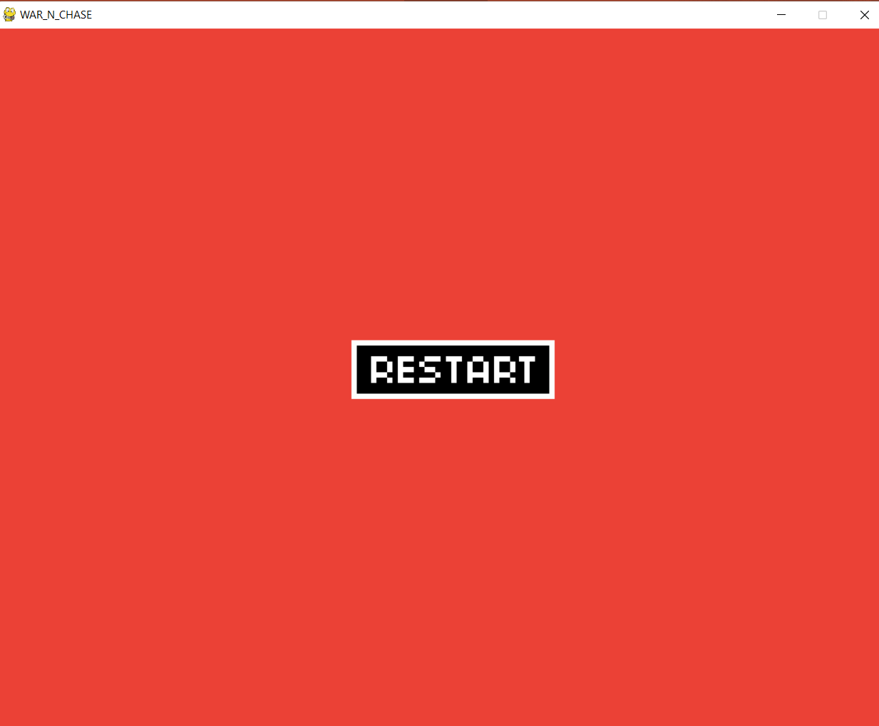

**FIGURE 4**

**WORKING OF THE PROJECT**

The project that we made is a 2D single player shooting game in which the aim of the player is to kill the enemies and complete a level.

This project uses the concept of Object Oriented Programming heavily and works mostly on the pygame library.

This project took a lot of time because first we have to learn few concepts of gaming such as randomness, graphics, fps, etc. In python there’s a pre-defined library named pygame which involves a lot of functions which are proved to be really helpful while building our project.

As this is our first project, we face a major problem regarding code handling but this obviously improve our code management skills.

But being our first project we learn a lot of new things from this project as well as from our guide also who really taught us so much.

As this is a game so we learn a lot about game development and scope of it too.

4

**RESULT ANALYSIS**

* On starting the game the user will be shown the main game screen.
* Where there would be a player controllable by the user and there would be many obstacles with a beautiful mountain scenery in the background.
* At the top right left corner of the game screen there would be a health bar which would be green in color at the starting of the game and as the health of the player decreases the health bar would start turning into red color.
* Below the health bar the ammo that a player has would be shown and they would decrease as the player starts shooting.
* Below which the no of grenades a player has are shown.
* Also there would be different item boxes available for the user to collect , such as ammo box, health box, grenade box.
* Whenever the user collects any item box the respective item will increase accordingly.
* The keys **A** and **D** would be used for the player movement in the left and the right direction respectively.
* The **W** key would be used to jump.
* The **Q** would be used to throw grenade.
* The **SPACE** key would be used to fire the bullets.
* The aim of the player would be to kill the enemies with bullets and grenades and complete the level by reaching the end.

5

**FUTURE SCOPE**

* Firstly, this game was selected so as to have a better command over python programming language and introduce oneself to games, So the game is quite old and isn’t played by many gamers today.
* But still many changes could be made in the game such as it could be made multiplayer game so two or more than two players can play the game and it would be more fun to play.
* Different guns could be added with different hitting ability.

6

**CONCLUSION**

The best way to learn something is by having fun while doing any work and enjoying it, so we can say games are one of the best ways to learn something.

While doing this project I and my teammate Mansha Sharma enjoyed programming the game so much because after writing few lines of code and running it we could see the output in the form of graphics and seeing our code work was wonderful.

This game helped us to understand the major concepts of Object Oriented Programming and learn about the pygame library which is used for 2D game making.

Also we got to know how games actually work, how the enemies move themselves, fire when they see a player and to be honest it surprised us many times the way games work and the logic behind it.

Finally, we would say that if there is any part in a programming language and you want to learn it games are the best way to learn it.

7

**REFRENCES**

* Below is the link of YouTube channel Coding With Russ , all the assets , concepts were taken from this channel .

<https://www.youtube.com/watch?v=1hXAq0Re2xA&list=PLjcN1EyupaQm20hlUE11y9y8EY2aXLpnv&index=13>

* Stack overflow and Geek for Geeks : These two websites helped us throughout our project to solve various errors and to learn any new concept required in the game.

<https://stackoverflow.com/questions/8609153/why-do-we-use-init-in-python-classes>

<https://www.geeksforgeeks.org/self-in-python-class/>

<https://www.geeksforgeeks.org/pygame-creating-sprites/#:~:text=Sprites%20are%20objects%2C%20with%20different,and%20down%20using%20arrow%20keys>.

8